VPC -01 TASKS

Create VPC with 2 private and 2 public subnets.
First created a vpc named myvpc
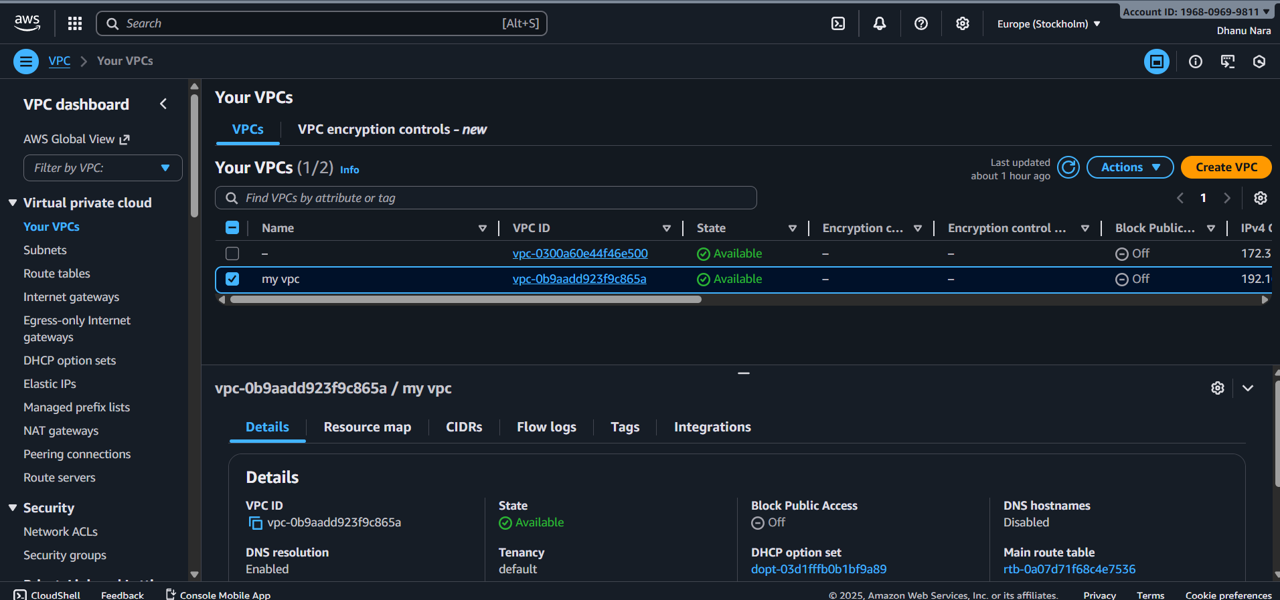
After creating a vpc we need to create a four subnets inside that in which two are public subnets and other two are private subnets.
Here the range of myvpc was 192.168.0.0/24.
So if we want to create any subnet it has to be in this range only.
1st public -subnet-1
192.168.0.0/28.

2ndpublic-subnet-2
192.168.0.16/28.

3rd private-subnet
192.168.0.32/28

4th private-subnet
192.168.0.48/28
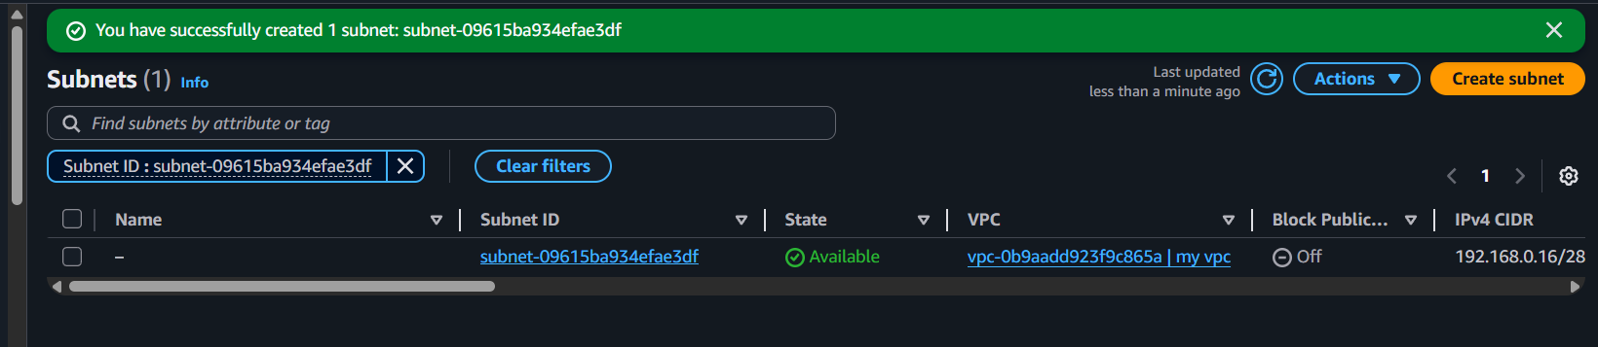
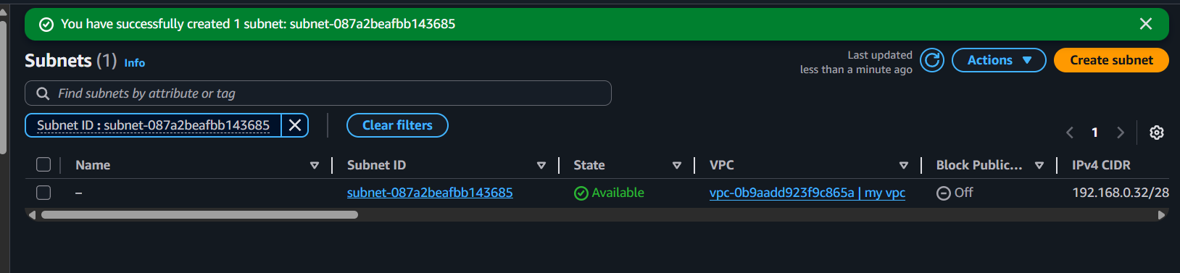
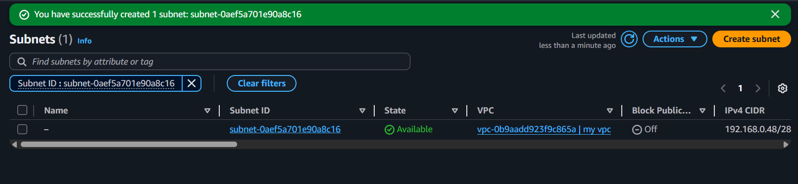
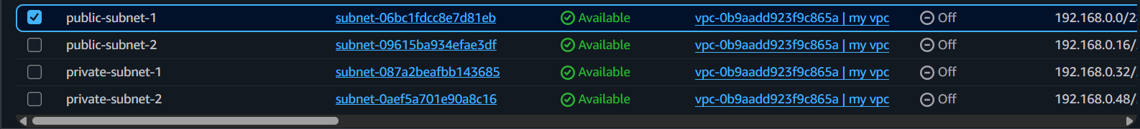

2.Enable DNS Hostname in VPC.
First we should go to create there click on VPC which was already created then go to actions.
After going into actions edit VPC settings.
Enable the DNS options. Turn ON both DNS resolution DNS hostnames.
Click save.

{We do enable DNS hostnames because if we launch any instance in a public subnet, it will get DNS name and that will work only when we enable DNS hostnames}
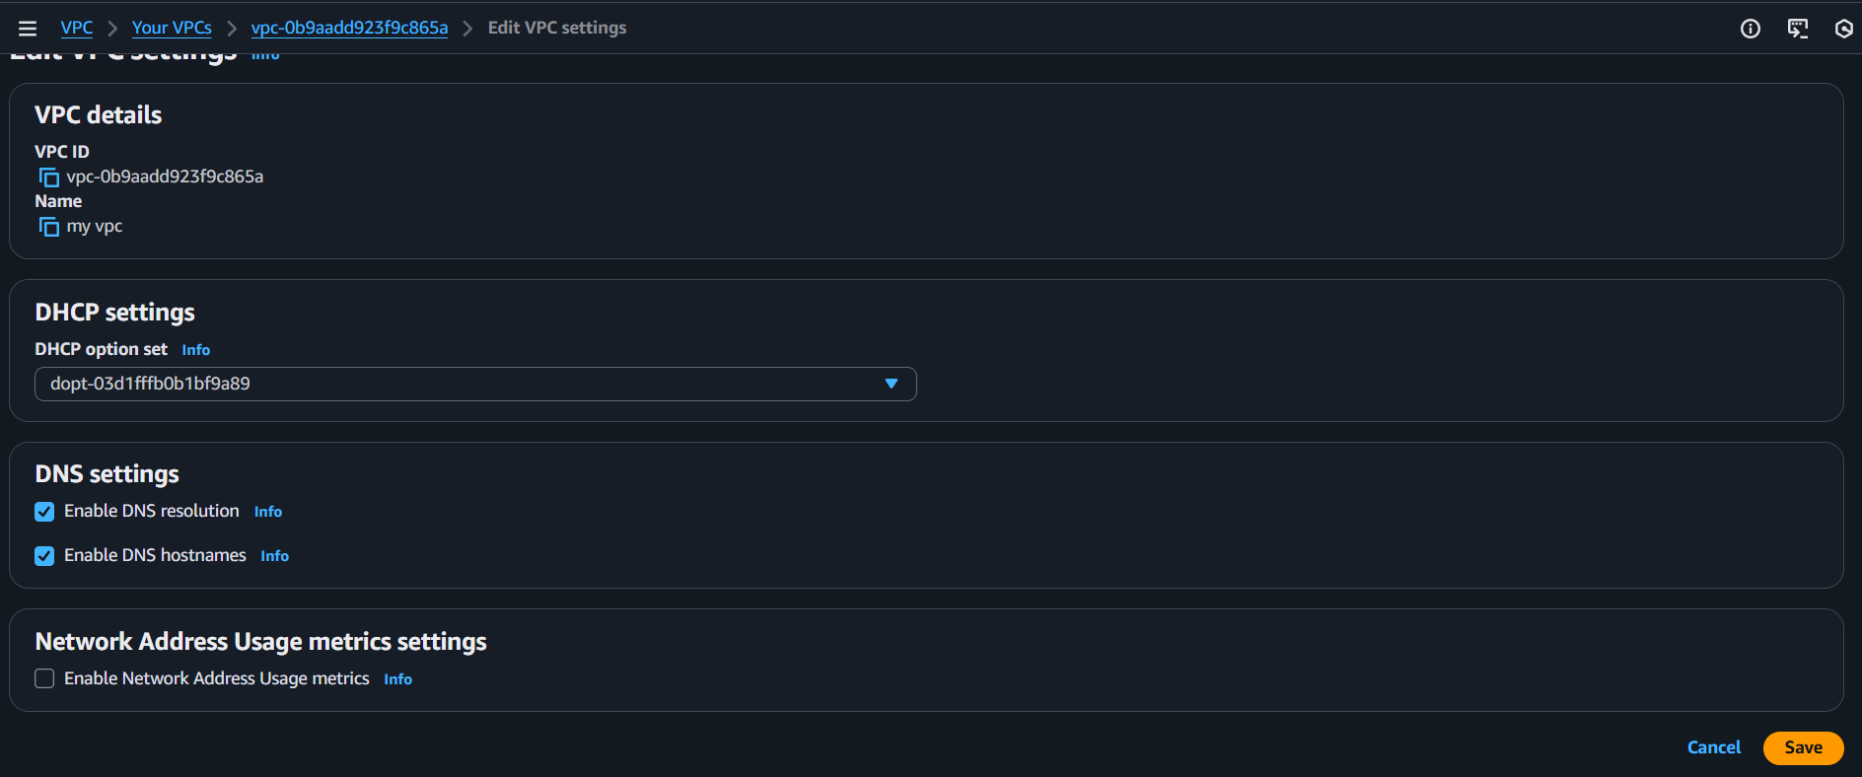
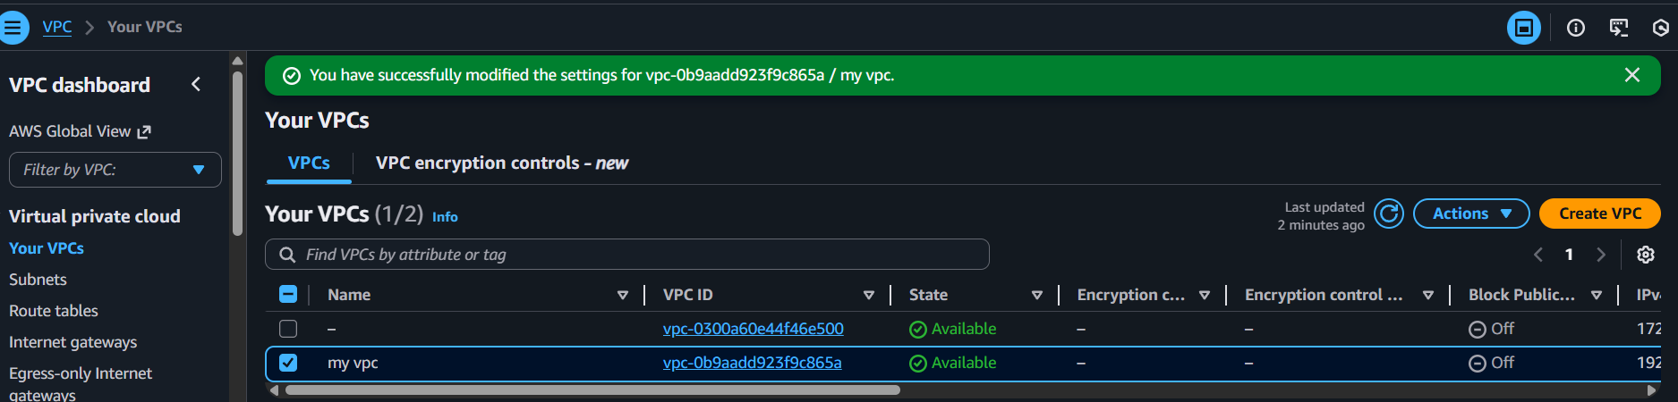

3.Enable Auto Assign public IP in 2 public subnets.
First we should go to VPC console and go to subnet and select your public subnet .
Click on actions
Enable public IP assignment
Click on save

{we enable this auto assign public IPv4 on public subnets . Because without a public IP , EC2 instances in a public subnet cannot access the internet and we cannot SSH into them from our laptop. Even if the subnet has IGW , the route table has IGW the VPC has DNS enabled
The EC2 still needs a public IP.
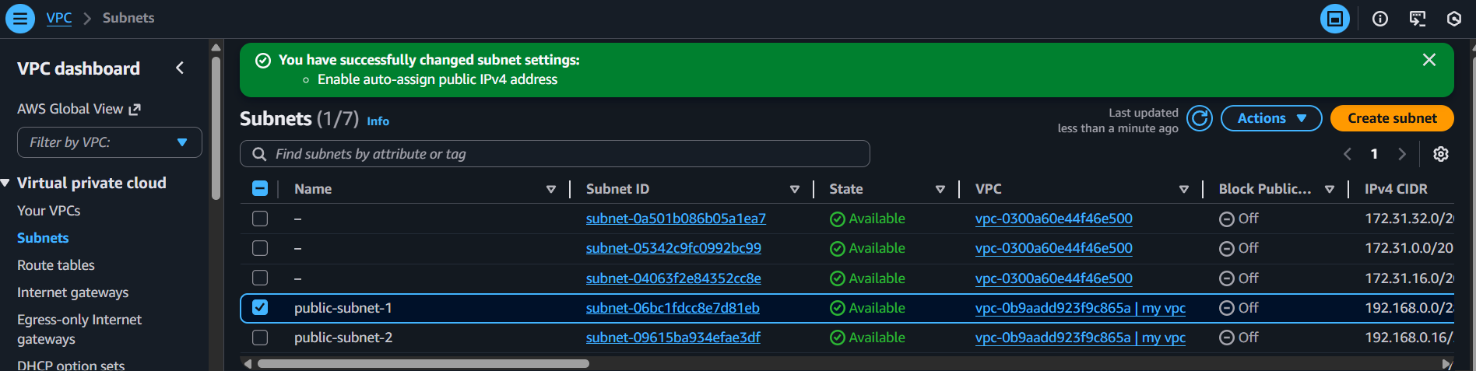
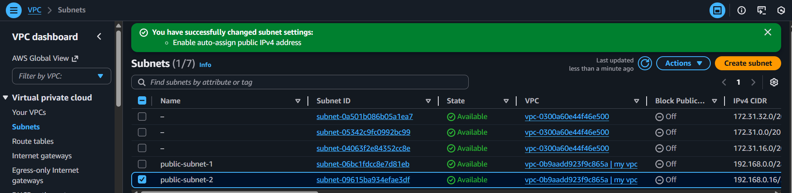
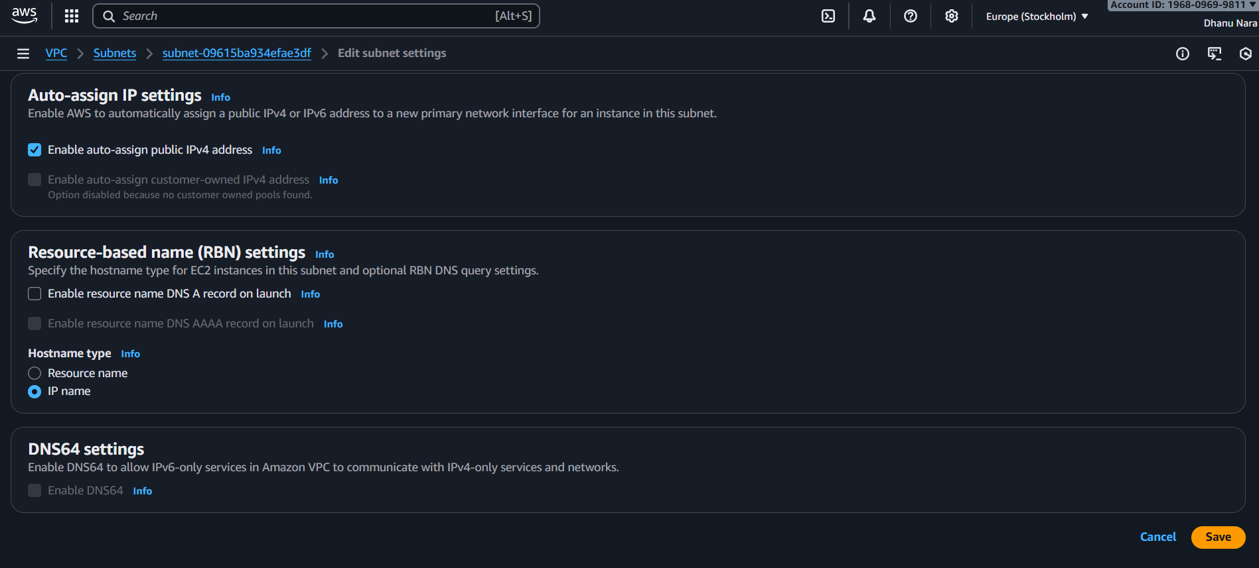

4.Add 2 private subnets in private route table.
First we should go to VPC and go to route table .
Create a route table named pri-rt
Open subnet associations
And edit subnet associations
Select the private subnets we want to add to private route table
Click save associations
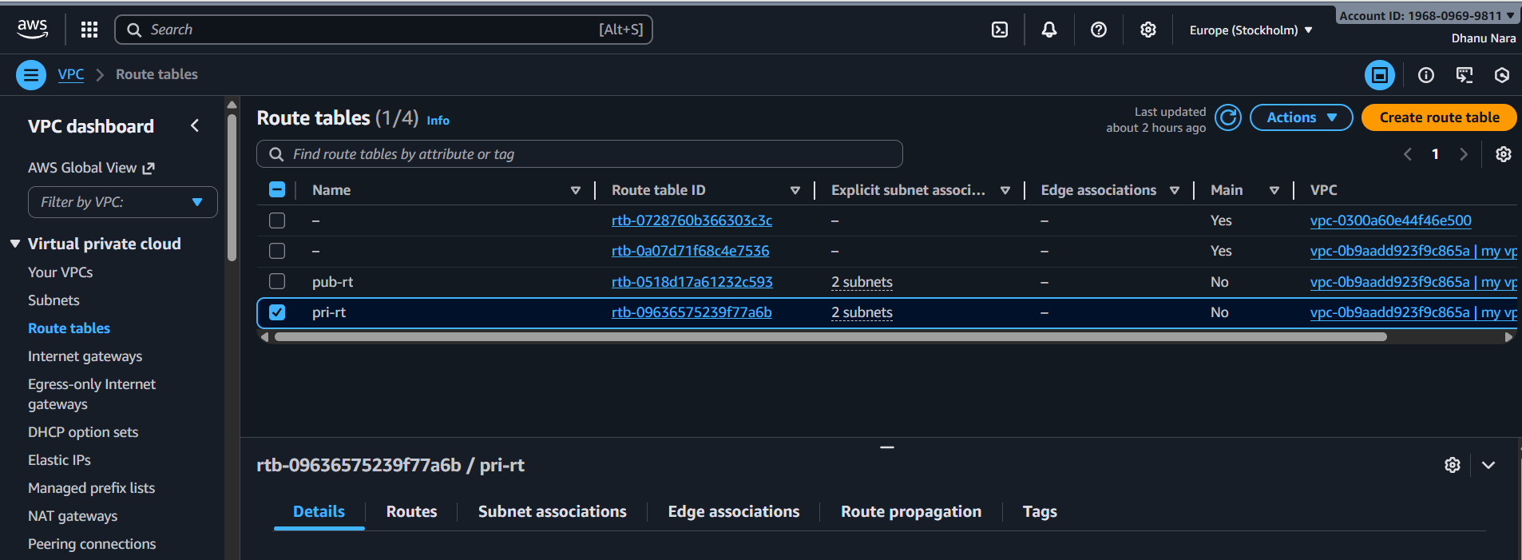.
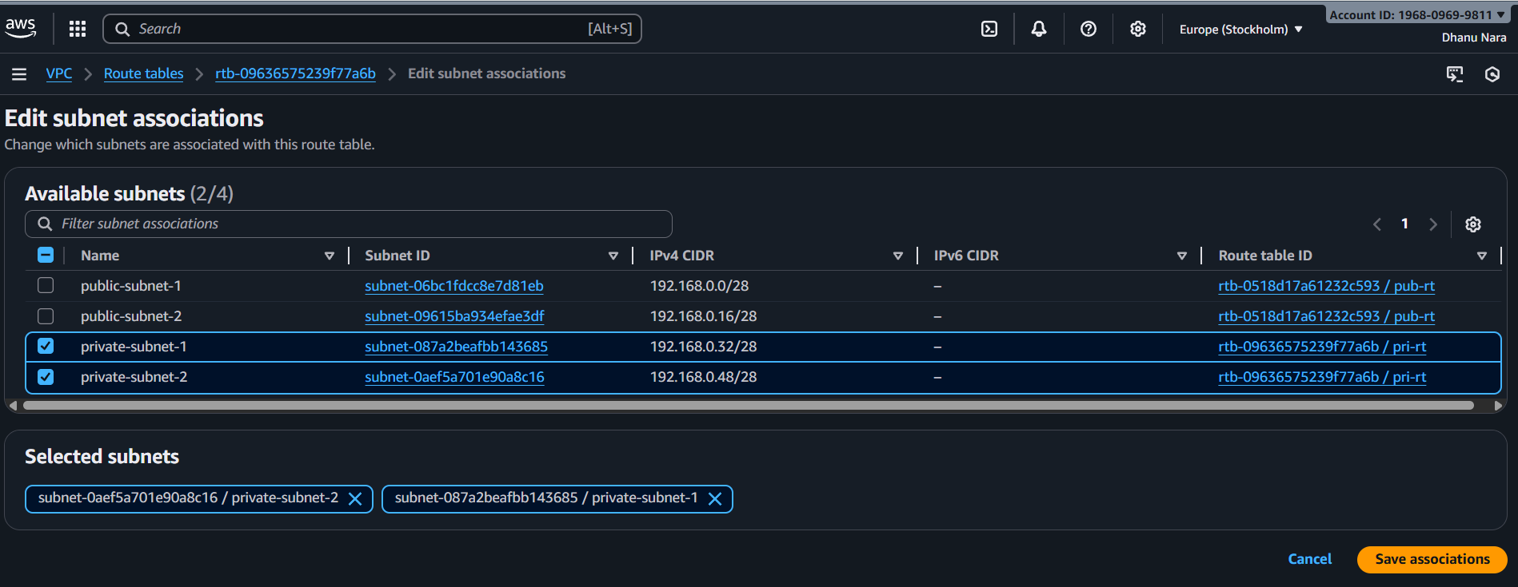

5.Add 2 public subnets in public route table.
Go to console go to route table and select pub-rt
Click on subnet associations and edit subnet associations.
Add the subnets and save associations.

Check weather IGW is attached or not
Go to Route tables
Select pub-rt
Click routes – Edit routes
Click add route
Enter Destination 0.0.0.0.0/0
Internet Gateway – my-igw
Click on save
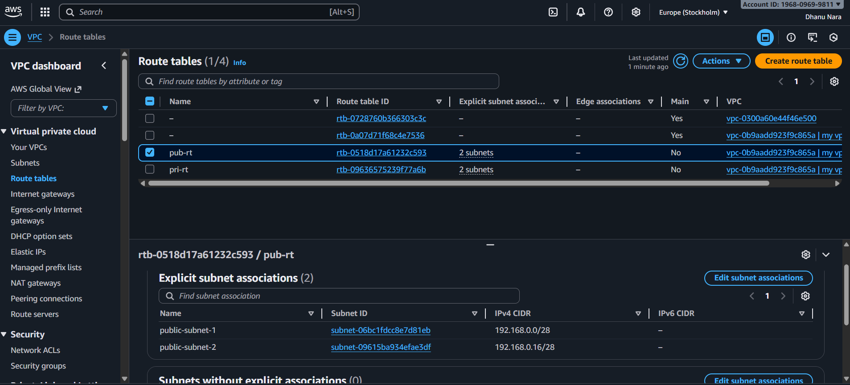
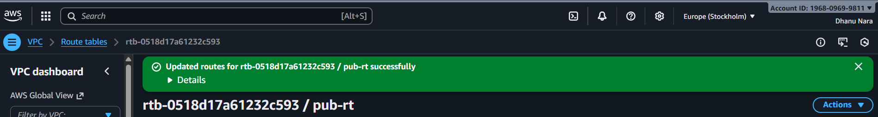

6.Public route table will have the routes to internet and local.
Local route automatically created and allows all subnets inside the VPC to communicate with each other.
Internet Gateway route added which gives internet access.
This is the route that makes the route table public.
And also subnet attached to this route table becomes a public subnet.
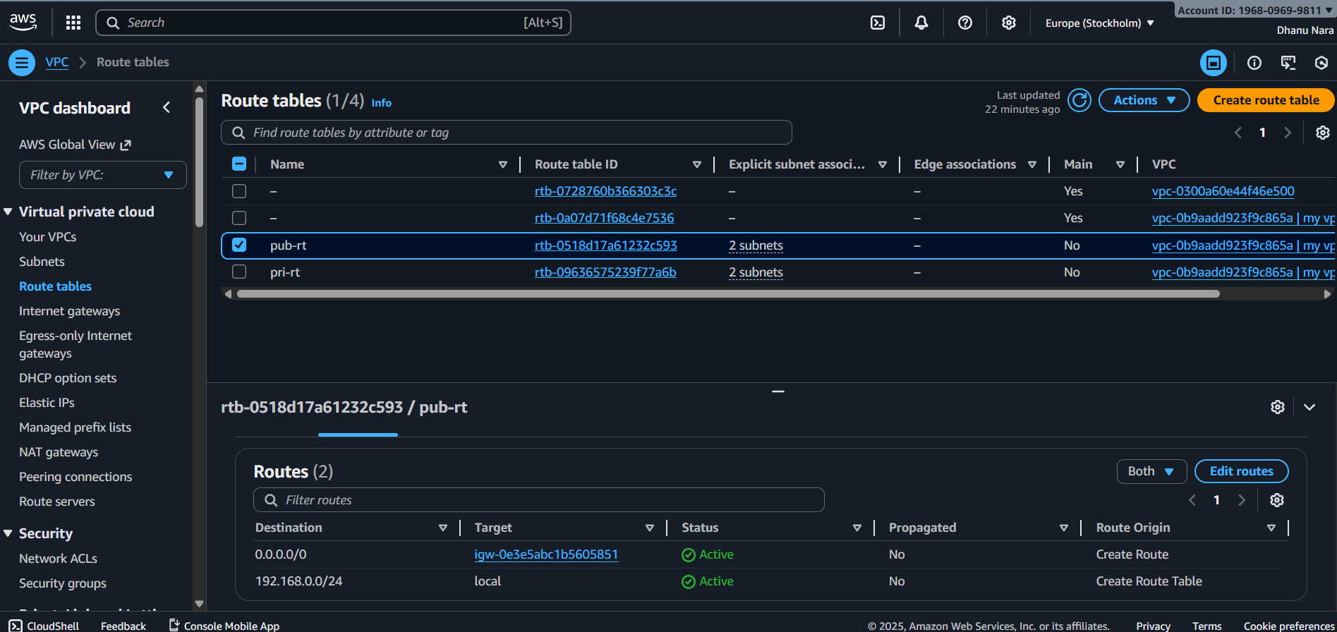

7.Create EC2 in public subnet with t2.micro and install PHP.
First launch an instance with name php-server
In network settings should choose our VPC and subnet our public-subnet-1
Configure security groups with a new security group name php-sg and in inbound rules type ssh and port no 22 and also http port 80 then launch instance.
Connect to ec2 using ssh and update and install httpd.
Then install PHP using sudo dnf install php php-cli php-common php-mysqlnd -y
Then create a php test file
sudo vi /var/www/html/info.php
<?php
Phpinfo();
?>
Save and exit.
Sudo systemctl restart httpd
Then browse httpd://PUBLIC-IP/info.php
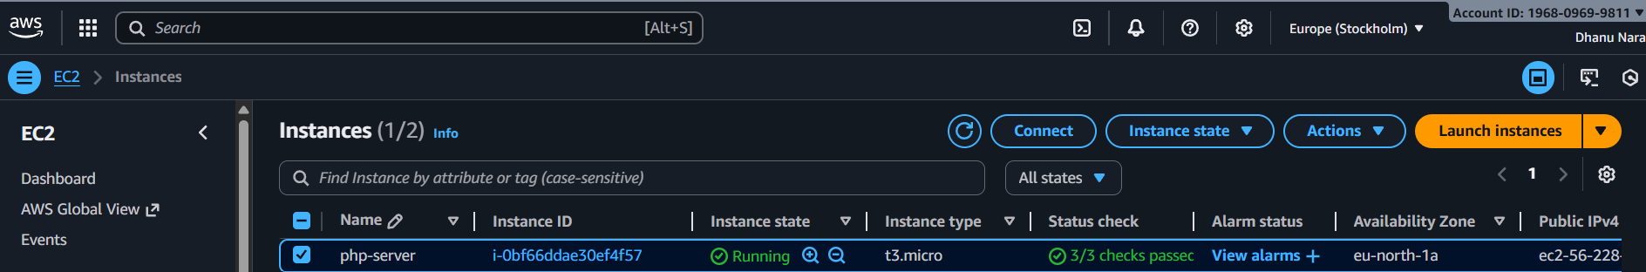
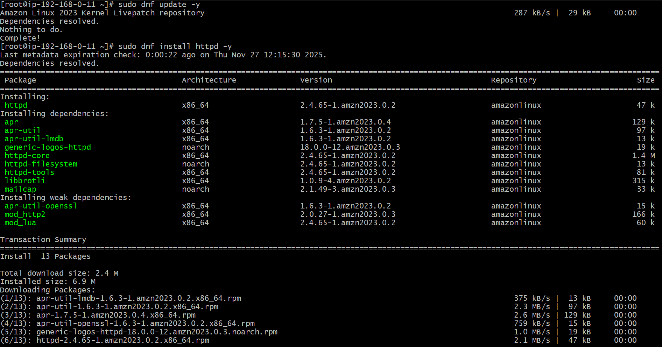
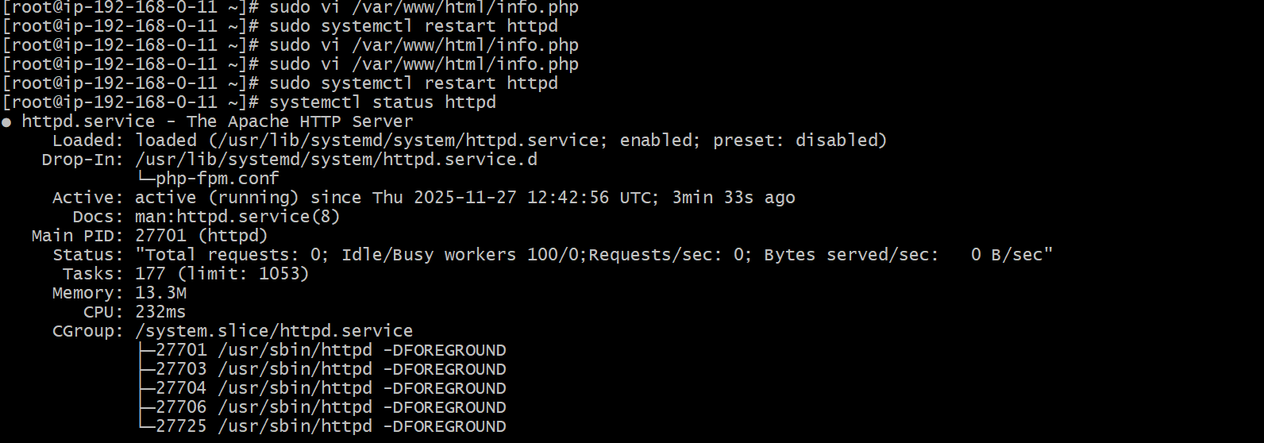
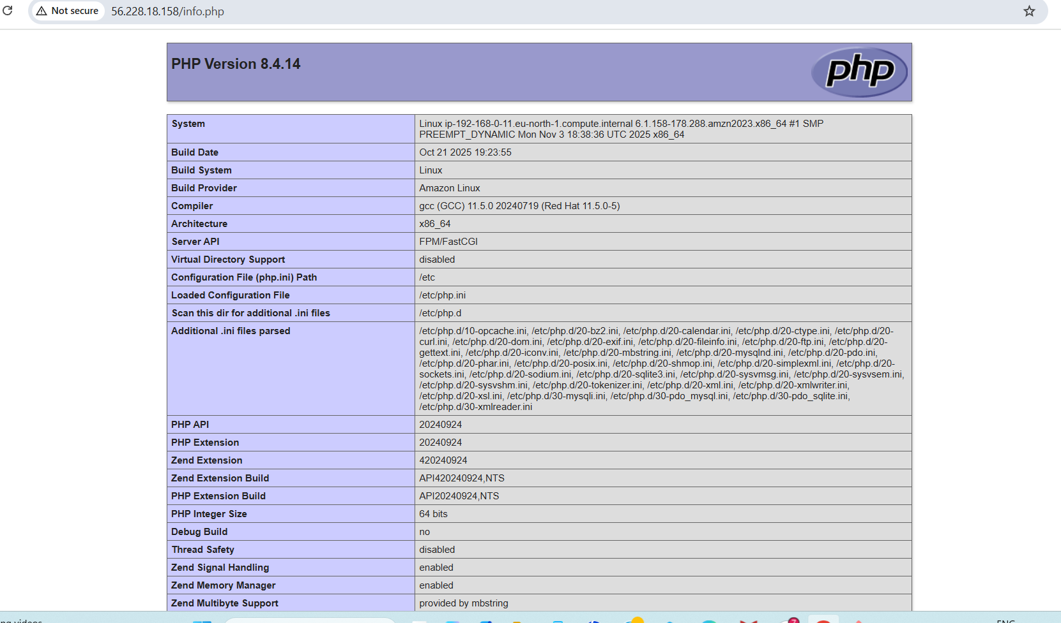

8.Configure NAT gateway in public subnet and connect to private instance.
First we need to create VPC and assign CIDR.
Create public subnet and private subnet and also enable auto assign public ipv4 for public subnet.
Create Internet gateway and attach that to VPC
Create public route table and attach Internet gateway to that so that now public subnet will get internet
Create NAT gateway in public subnet and allocate an Elastic IP.
Create private route table and attach NAT gateway to that.
Now launch two instances one with where we should select public subnet in one and select private subnet in another one.
Now connect to first instance with public IP and check the private IP with ping it will work.
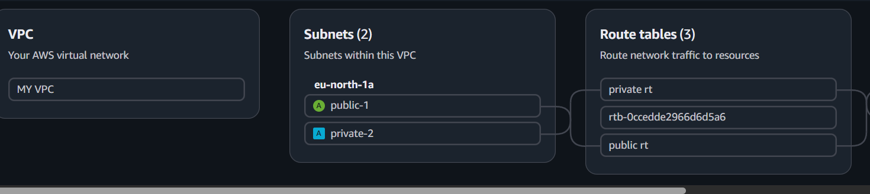
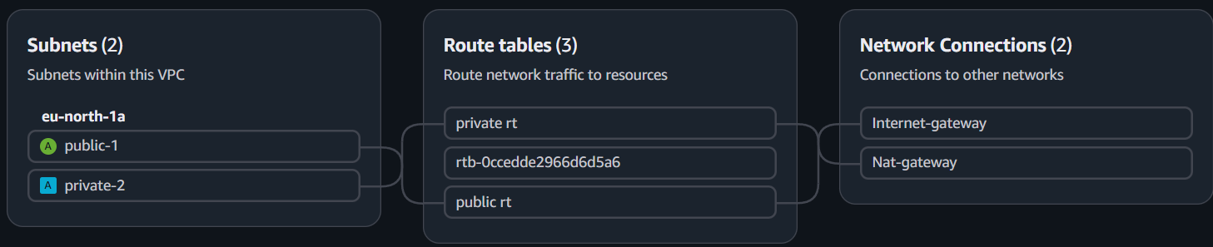
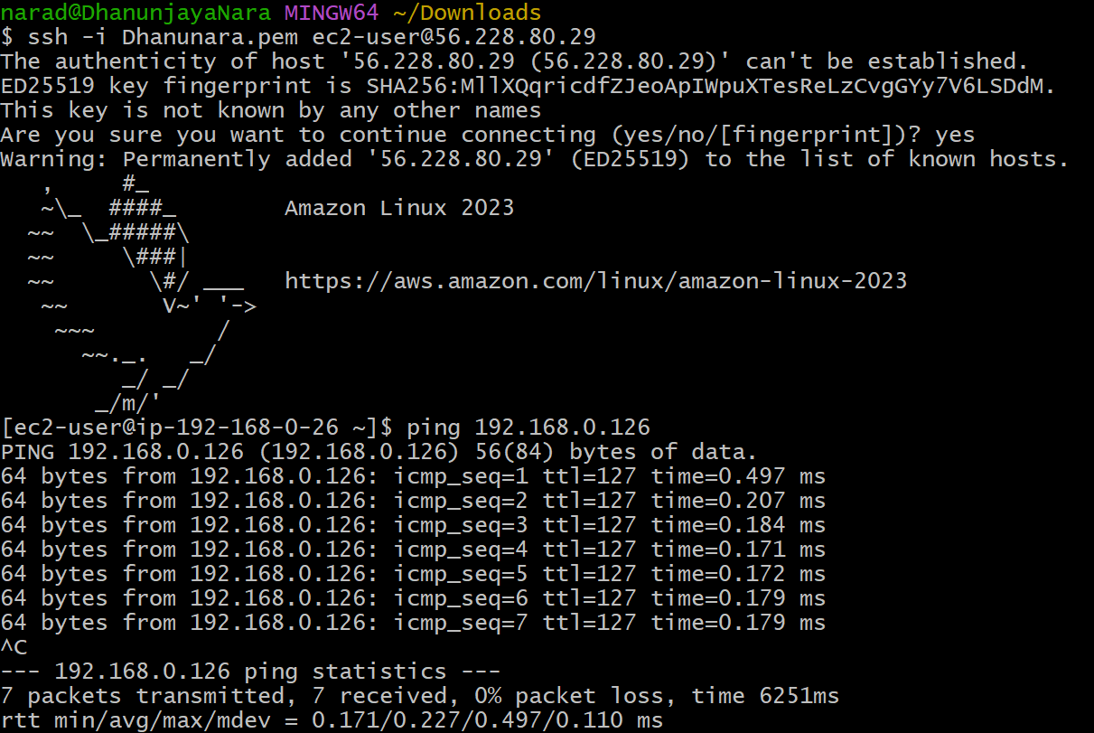

9.Install Apache Tomcat in private EC2 and deploy a sample app.
First we need to create VPC and assign CIDR.
Create public subnet and private subnet and also enable auto assign public ipv4 for public subnet.
Create Internet gateway and attach that to VPC
Create public route table and attach Internet gateway to that so that now public subnet will get internet
Create NAT gateway in public subnet and allocate an Elastic IP.
Create private route table and attach NAT gateway to that.
Now launch two instances one with where we should select public subnet in one and select private subnet in another one.
Now if we try to ssh ec2-user IP it will ask for the file of key.
Now open git bash in downloads and cat the pemkey and paste that in file using vi and also give chmod permissions.
Now ssh filename ec2-user IP it will get connect.
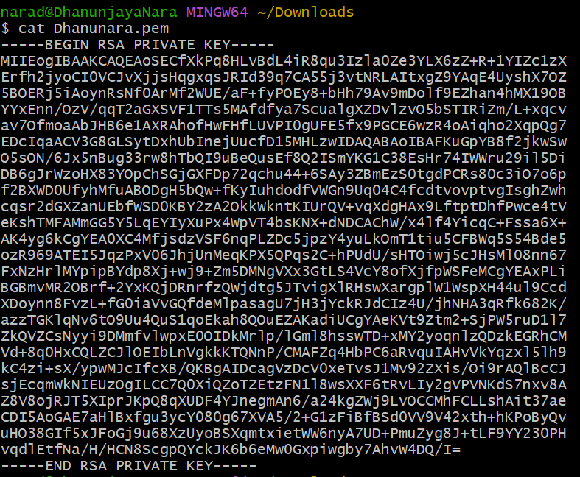
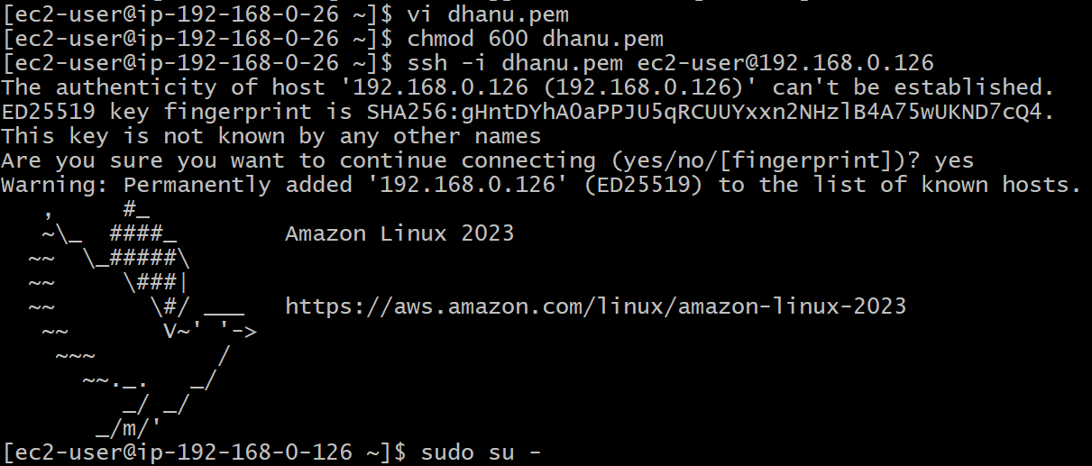
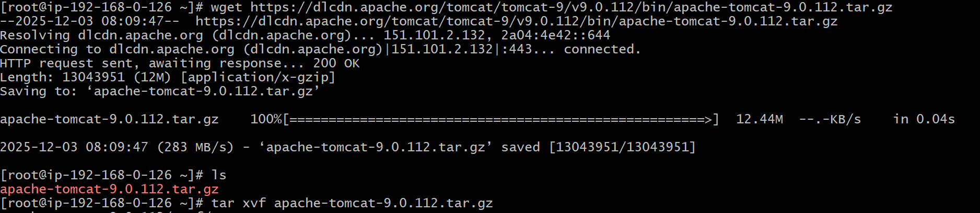
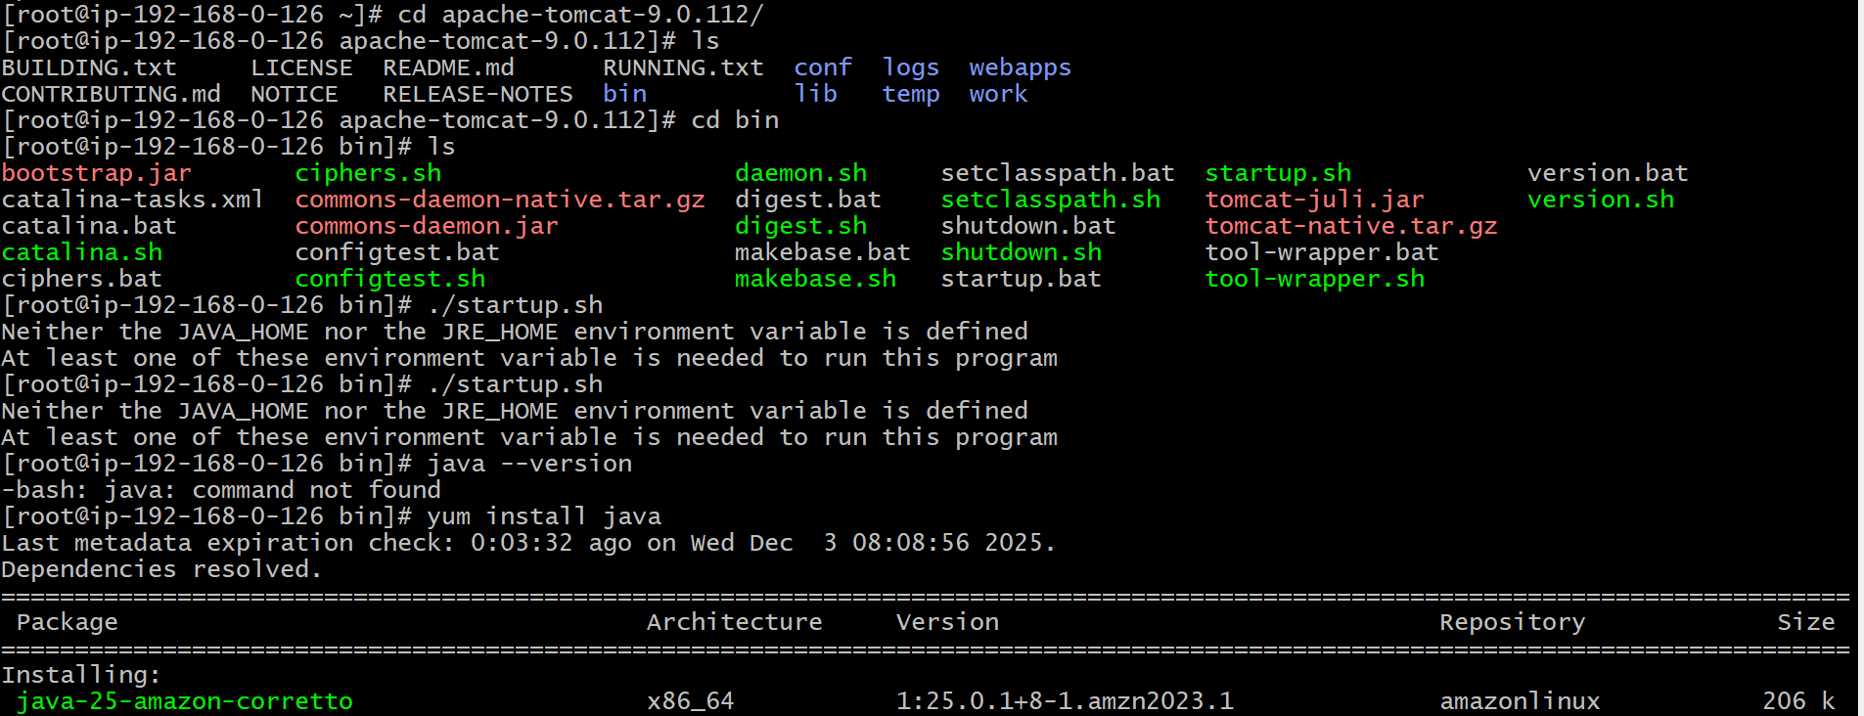
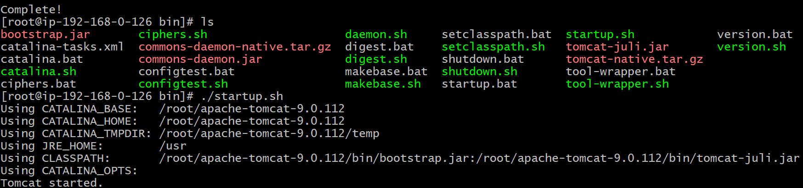
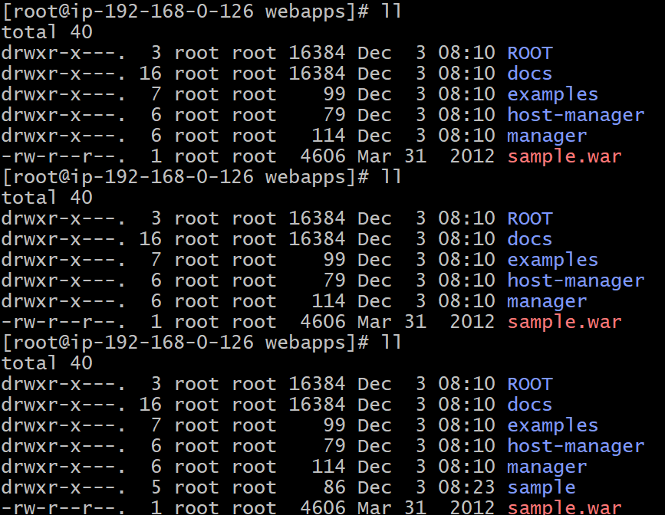

10.Configure VPC flow logs and store the logs in S3 and cloudwatch.
First we need to create flowlog in VPC.
In that we need to provide storage option so we need to create S3 for that.
And if we do any activity in AWS it will store all the info.
And after going to S3 if we do refresh we will find the recently performed activity.
Again create one more flowlog and there we need to keep the destination to cloudwatch
Cloudwatch will momitor all the things of a server.
In this again we need to create a policies and roles in IAM .
And after going to cloudwatch if we refresh we will find the recently performed activity of AWS.
